No. | Picture | Product Link | Colour | Size | Quantity | Unit Price | Total Price  (RMB) | Shipping Cost to Agent | Total | Remark
1 | 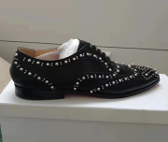 | btqwm | Black | 41 | 1 | ¥439.00 | ¥439.00 | ¥0.00 | ¥439.00
2 |  | btqwm | Black | 42 | 1 | ¥439.00 | ¥439.00 | ¥0.00 | ¥439.00
20 |  |  |  |  |  |  | ¥0.00 |  | ¥0.00
 | TOTAL |  |  |  | 2 |  | ¥878.00 | ¥0.00 | ¥878.00
China Shopping Fee |  |  |  | 5% |  | ¥50.00
Total Amount to send to China |  |  |  |  |  | ¥928.00
Total in US$ |  |  |  | 6.38 |  | $145.45

